1. Arithmetic Operations in 8085 Microprocessors
a. 8-BIT ADDITION WITH CARRY USING DIRECT ADDRESSING

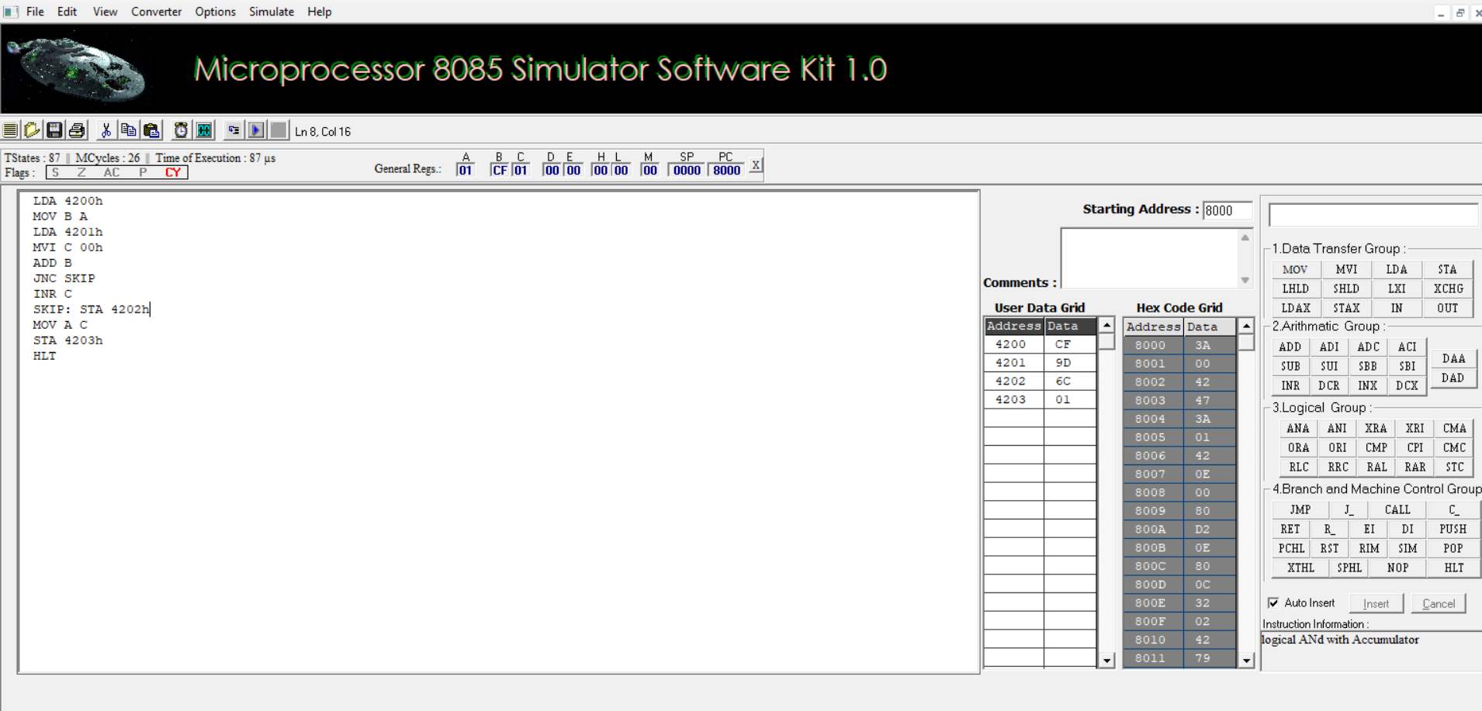

b. 8-BIT ADDITION USING INDIRECT ADDRESSING

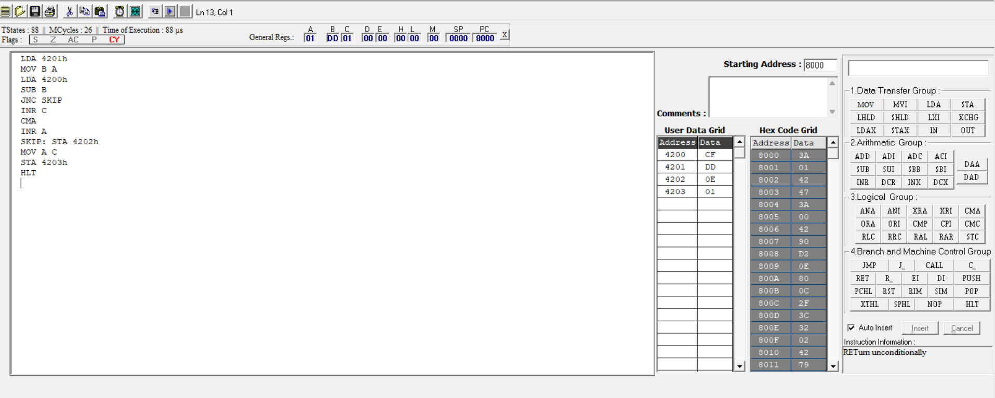

c. 8-BIT SUBTRACTION WITHOUT BORROW
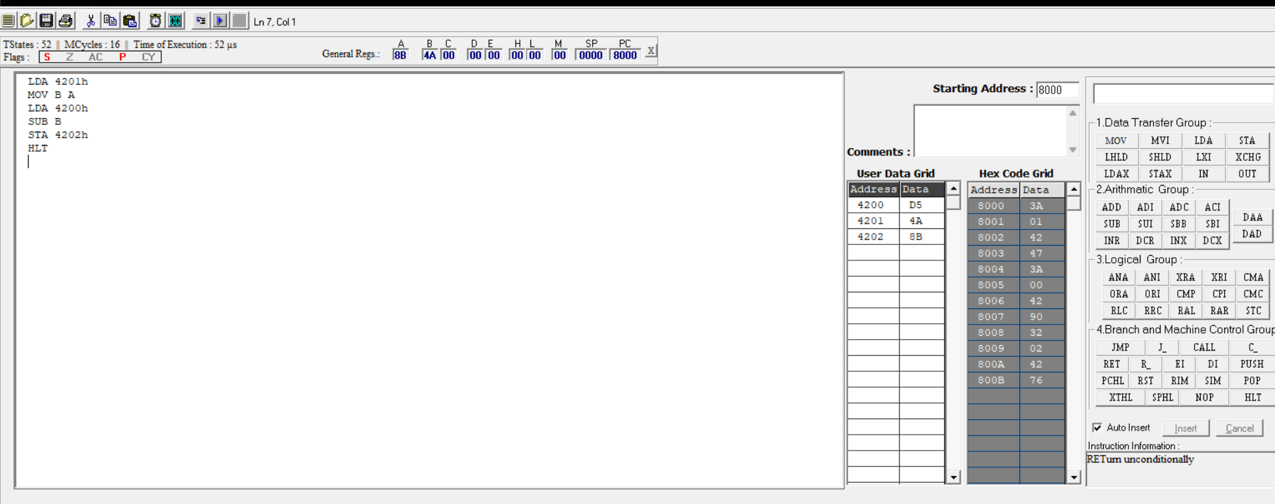

d. 8-BIT SUBTRACTION WITH BORROW USING DIRECT

ADDRESSING
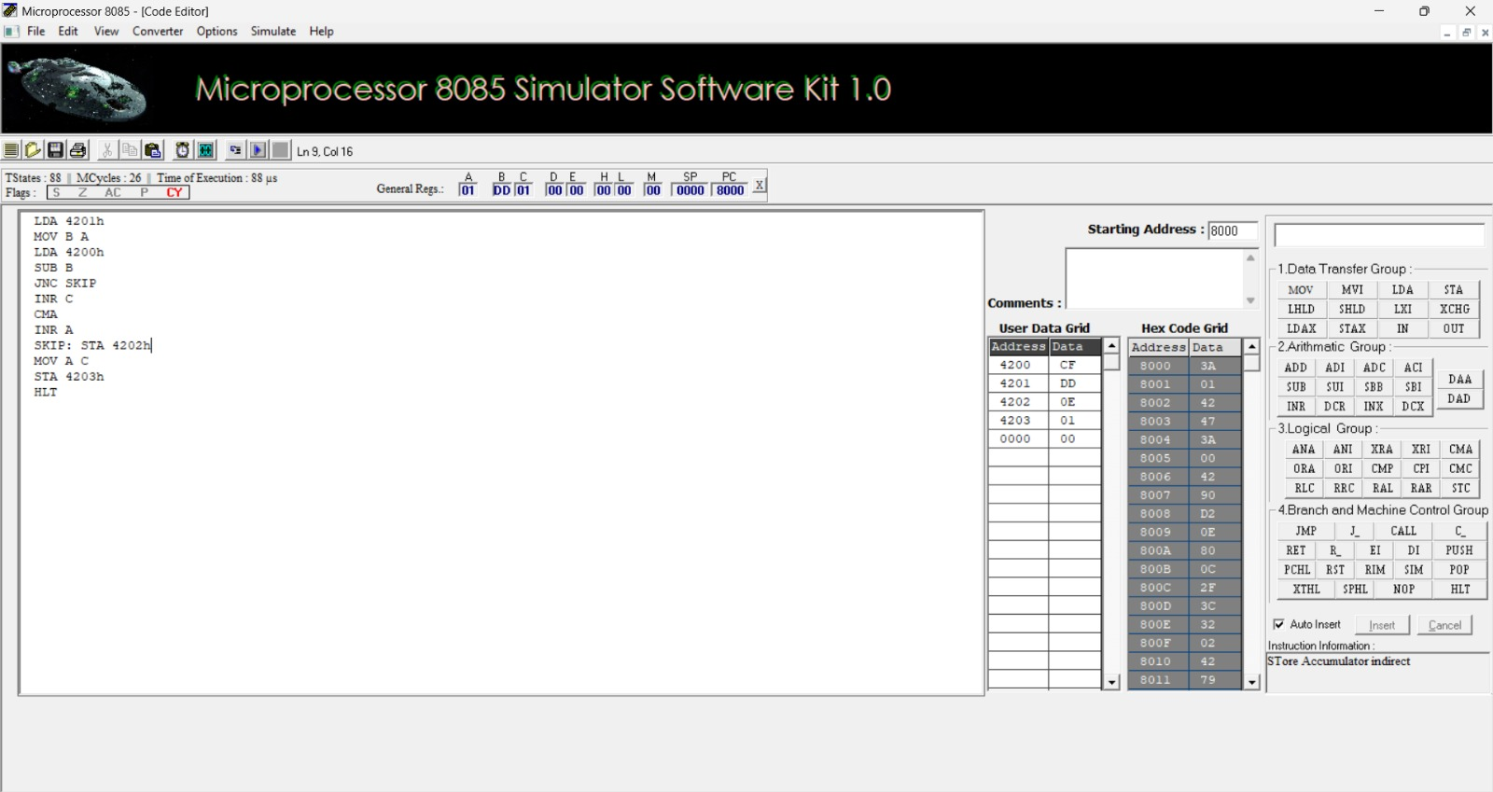

e. 8-BIT MULTIPLICATION OPERATIONS USING 8085

MICROPROCESSOR
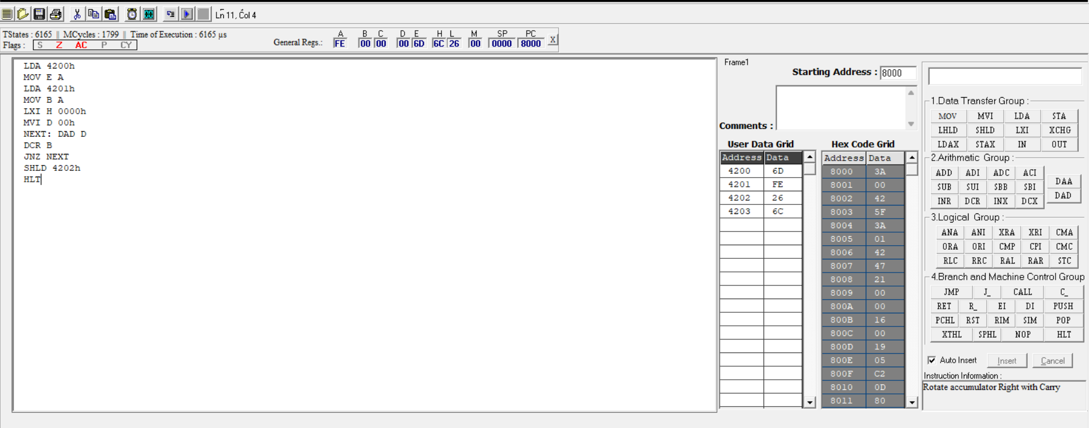

f. 8-BIT DIVISION OPERATIONS USING 8085

MICROPROCESSOR

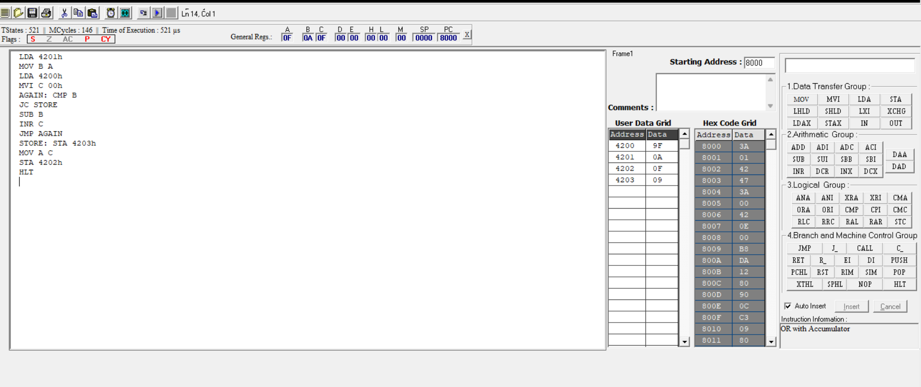

2a.SORT AN ARRAY OF DATA IN ASCENDING ORDER
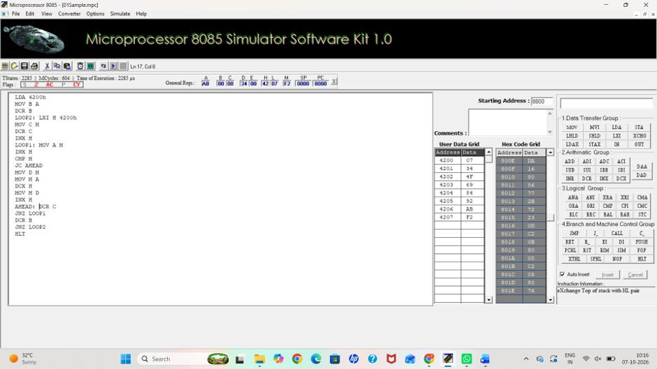
2b. SORT AN ARRAY OF DATA IN DESCENDING ORDER
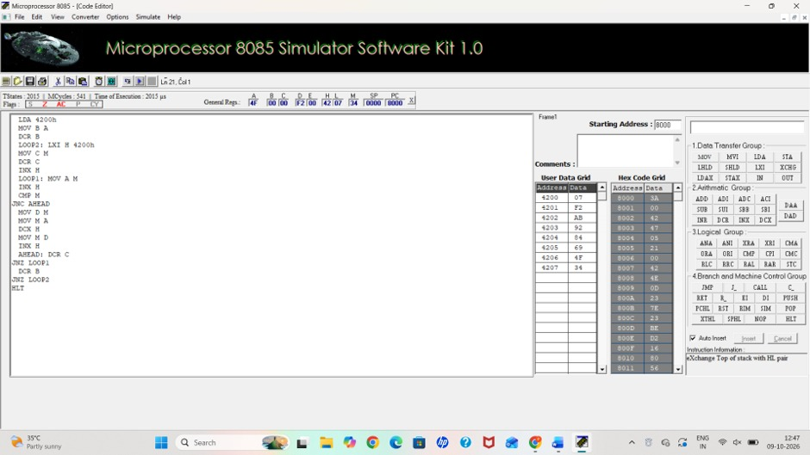

3. ASCII CODE TO HEX CODE CONVERSION
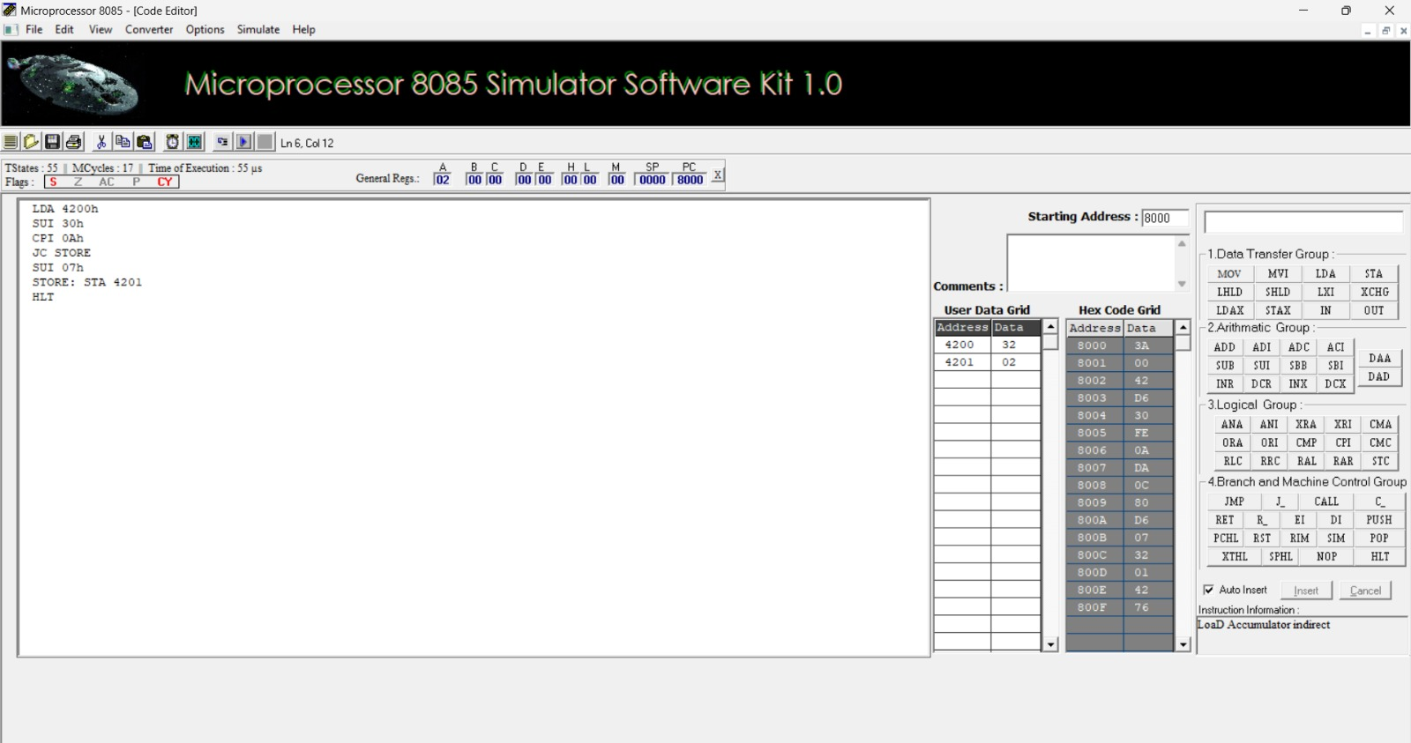
4.TRANSFERRING A BLOCK OF DATA BETWEEN MEMORY LOCATIONS
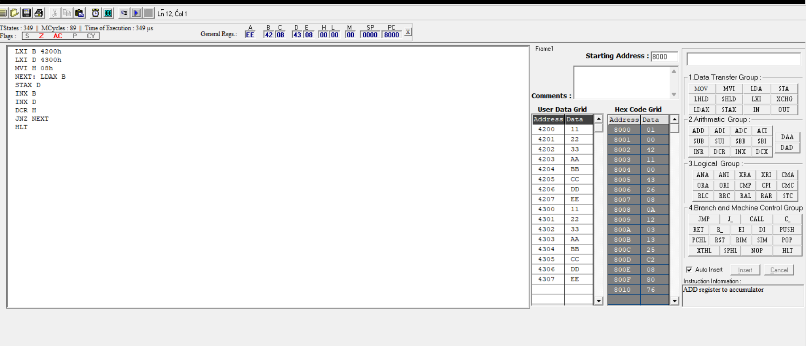

5a. MASKING AND SETTING OF LOWER NIBBLES ON GIVEN DATA
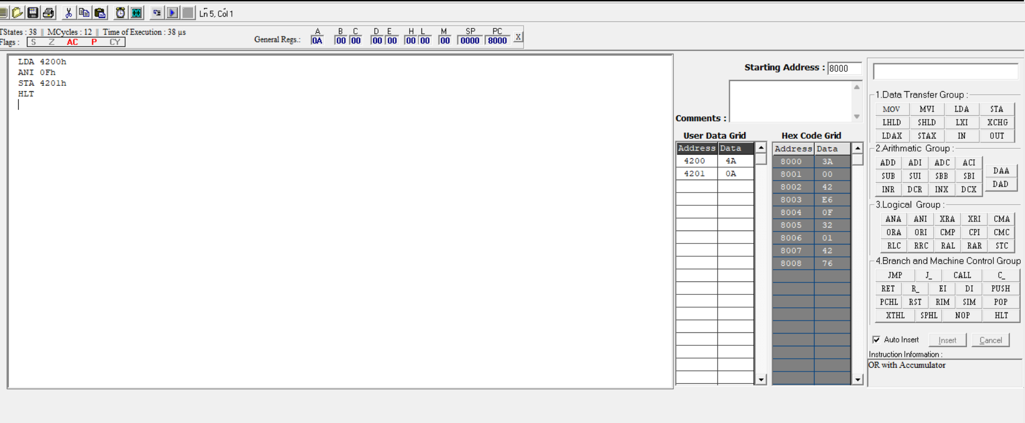

5b.ONE’S AND TWO’S COMPLEMENT
